# How to download ISAPI document from TPP

## Registering an TPP Account

1. Navigate to the site using this link: [tpp.hikvision.com](https://tpp.hikvision.com/)
2. Click on the “Register” button in the top right corner
3. Fill out the form and click to complete the OneHikID* registration
4. Read and accept the Terms of Use and Privacy Policy, then click on “Next step”
5. Enter your company information and admin contact information
6. Submit your registration and await approval

We will review your listing and publish your company information as soon as it is

approved. If declined, we will contact you to remediate the problem. **The process takes usually 1-3 business days.**

## Online Signing Process to Access Restricted Material（MLA）

1. Click Support/Download on the top menu to launch the online signing process
2. You can choose Materials License Agreement (MLA) to sign

Materials License Agreement (MLA): A general legal document for obtaining Hikvision’s

patented device-related materials, such as ISAPI.

**The process takes usually 2-3 business days.**

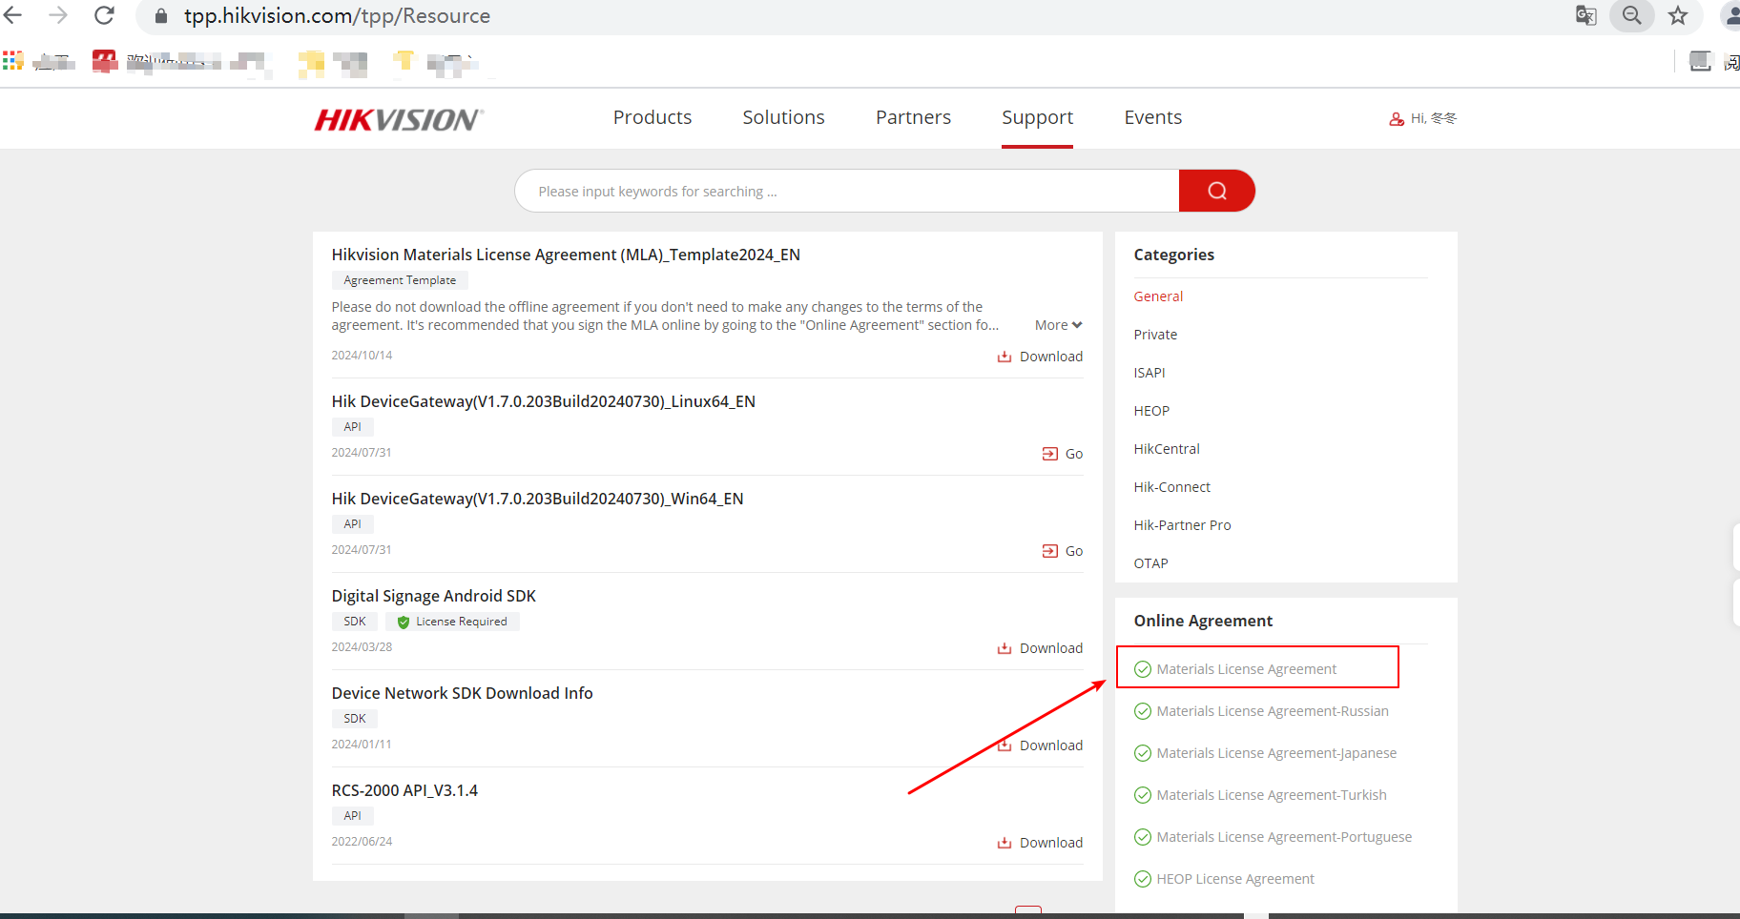

## Search ISAPI documentation by device model

1. click “Support/Download/[ISAPI Developer Guides](https://tpp.hikvision.com/download/ISAPI_OTAP)” or using this link https://tpp.hikvision.com/download/ISAPI_OTAP

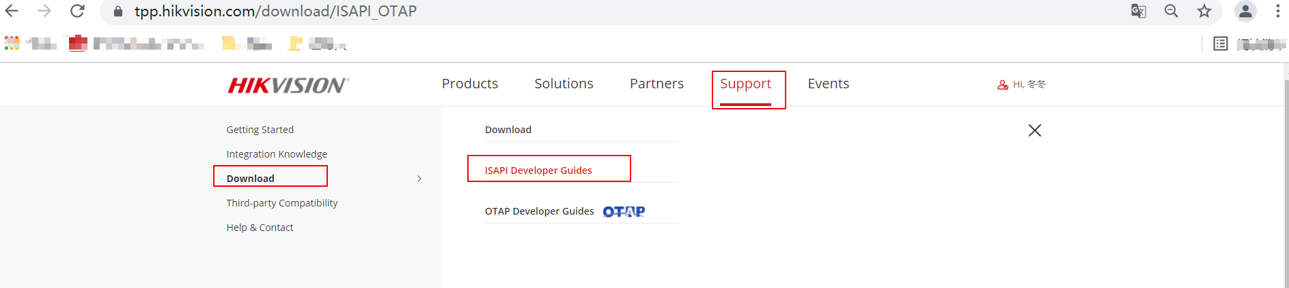

1. Search & download document

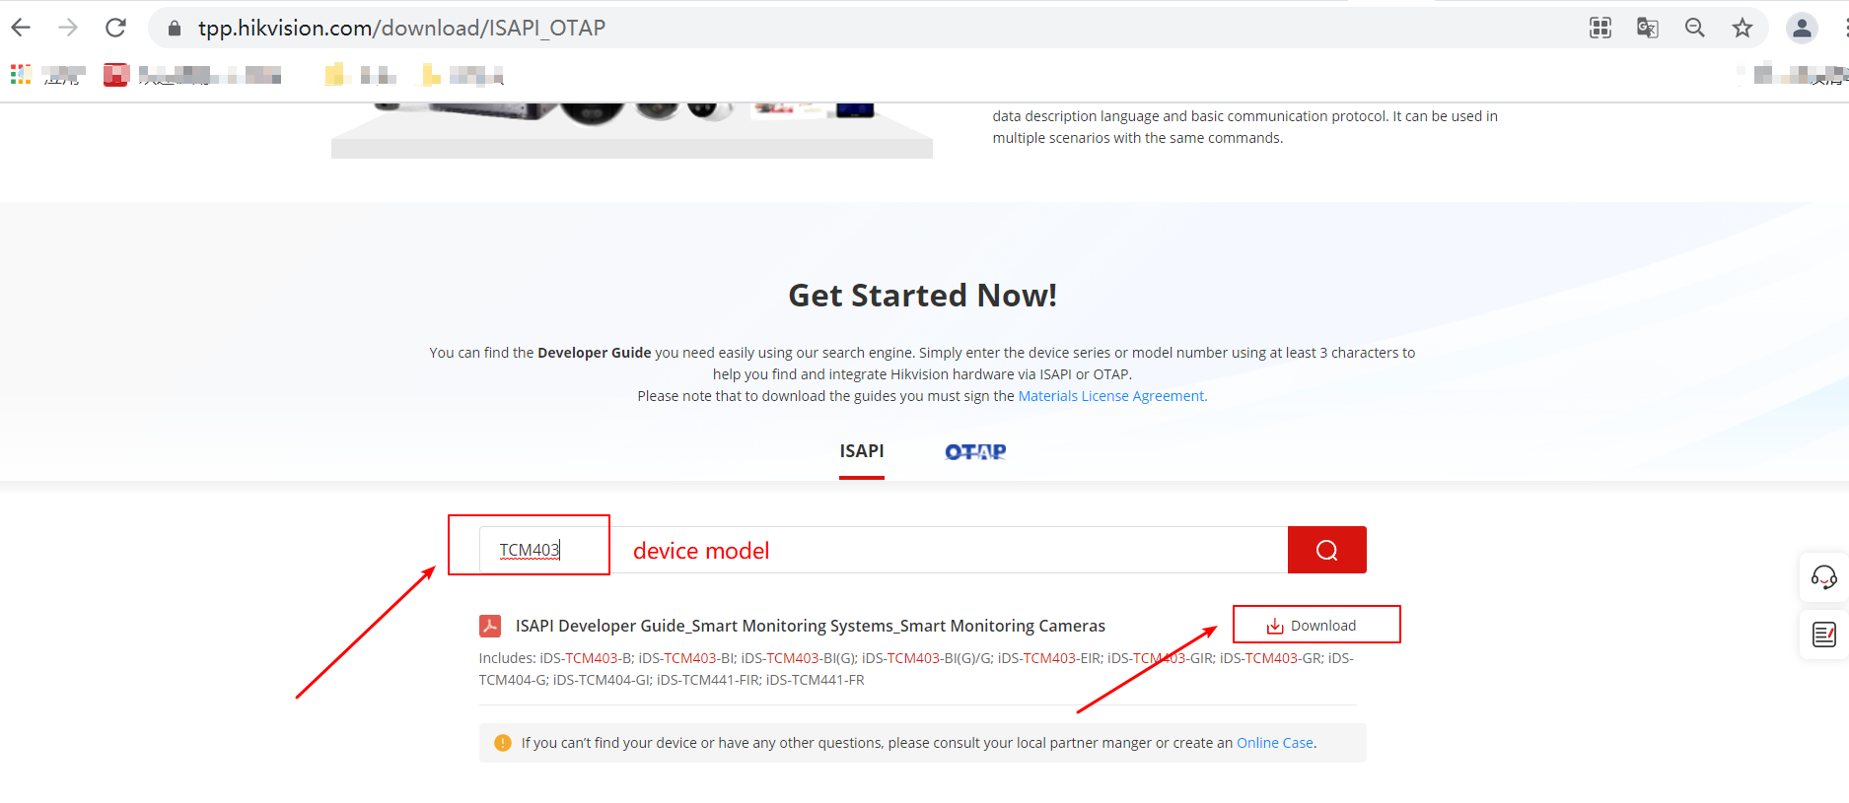

After decompression, you can see the specific ISPAI development guide document. Different device models correspond to different documents, and the document file names are different.

